UNIT VI: Selenium Tool

Q1. Explain WebDriver.
Selenium WebDriver is the most important component and the core of the modern Selenium suite (Selenium 2, 3, and 4). It is an open-source API (Application Programming Interface) and a tool that allows you to automate tests by controlling web browsers.
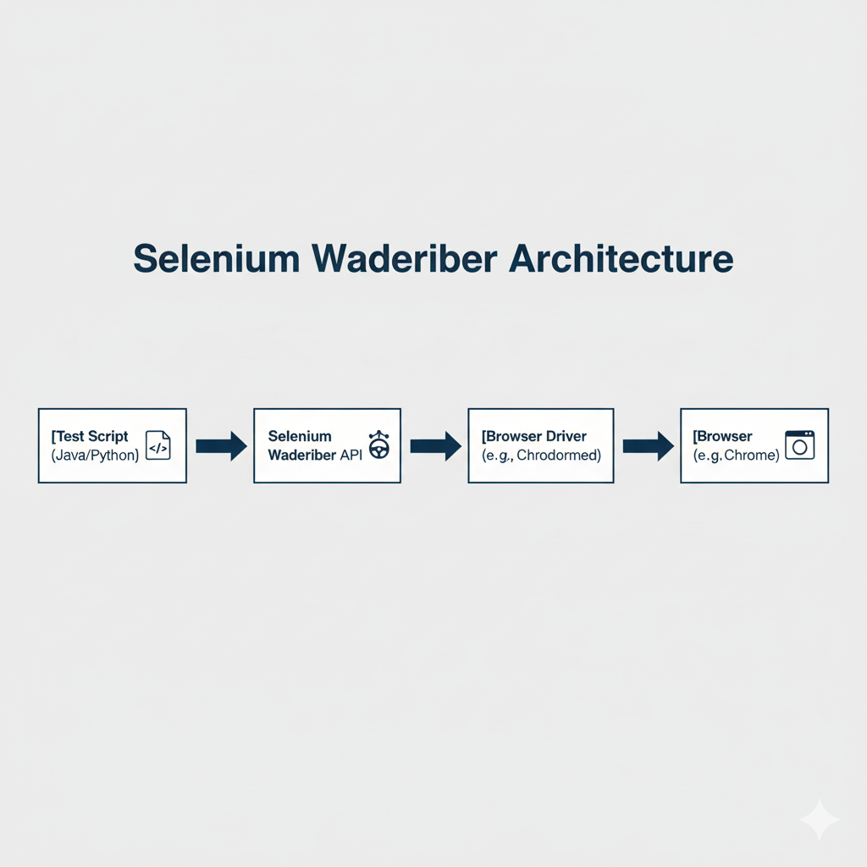
How it Works (Key Concept): Unlike older tools, WebDriver interacts directly with the browser, just as a real user would. It does not use a proxy server or inject JavaScript.
This is achieved through a specific architecture:
- Test Script: This is the code you write in a language like Java, Python, or C#. It contains WebDriver commands (e.g., findElement(), click(), sendKeys()).
- Browser Driver: This is a separate, small executable file that acts as a "translator" or "bridge." Each browser has its own driver (e.g., chromedriver.exe for Chrome, geckodriver.exe for Firefox).
- Browser: The actual web browser (e.g., Chrome) that the driver controls.
The Process: When you run your test script, the WebDriver API sends your commands (in a standard format called W3C Protocol) to the browser driver. The driver then "translates" these standard commands into the browser's native, internal commands and executes them. This direct-control method makes WebDriver very fast, stable, and reliable.

Q2. Explain Selenium Grid.
Selenium Grid is a component of the Selenium suite that is used for parallel and distributed testing. The main purpose of Selenium Grid is to dramatically reduce the time it takes to run a large test suite. It does this by allowing you to run your tests on multiple machines, with multiple browsers, all at the same time (in parallel).
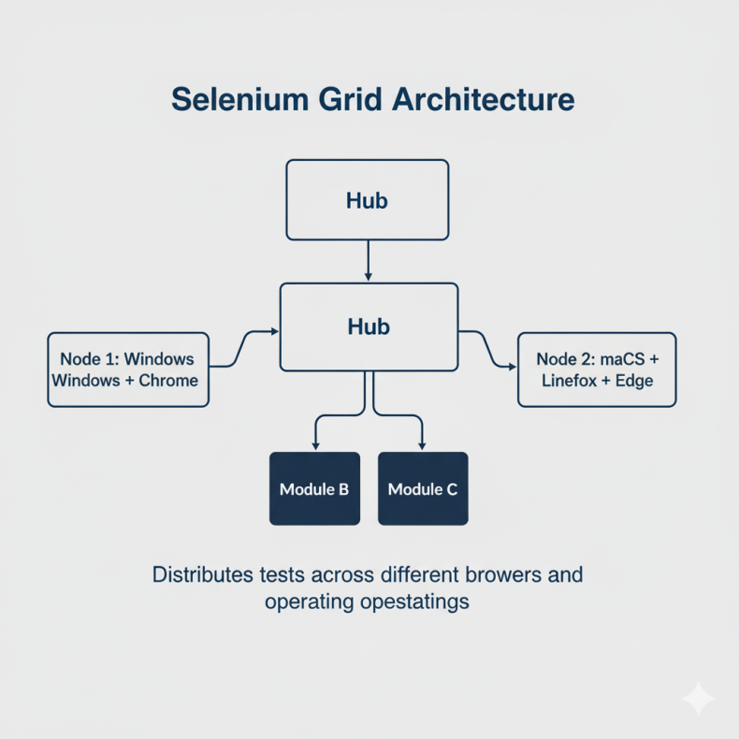
How it Works (Architecture): Selenium Grid uses a Hub and Nodes architecture:
- Hub: This is the central server or "master" machine. Its job is to receive all the test requests from your test script. It does not run any tests itself. It just manages the list of available "nodes" and distributes the tests to them.
- Nodes: These are the "worker" or "slave" machines. They are the machines that actually run the tests. A node machine registers itself with the Hub, telling the Hub what browsers and operating systems it has available (e.g., "I am a Windows 10 machine and I have Chrome and Firefox").
Example Workflow:
- You have a large regression suite of 100 tests.
- You set up a Grid with one Hub and 10 Nodes.
- You run your test suite and "point" it at the Hub.
- The Hub receives the 100 tests and sees it has 10 available nodes.
- It sends one test to each node. As soon as a node finishes, the Hub sends it the next test in the queue.
- By running 10 tests in parallel, the entire suite finishes in (roughly) the time it would take to run 10 tests, instead of 100.
This is also essential for cross-browser testing (e.g., running the same login test on Chrome, Firefox, and Safari at the exact same time).

Q3. Explain Software Test Automation through Selenium open source tool.
Software Test Automation with Selenium is the process of using the Selenium tool suite to control a web browser to automatically verify that a web application is working as expected.
This process involves several key steps:
- Select a Programming Language: First, the tester chooses a language. Selenium supports many popular languages, such as Java, Python, C#, JavaScript, and Ruby.
- Set up the Environment: The tester sets up a project (e.g., a Java project) and adds the necessary Selenium WebDriver libraries. They also download the required Browser Driver (e.g., chromedriver.exe).
- Write a Test Script: The tester writes a program (a "test script") using WebDriver commands to automate the user's actions. A typical script follows this pattern:
  - Arrange: Open a browser and navigate to the application's URL (e.g., driver.get("https://example.com")).
  - Act: Interact with elements on the page. Find an element (e.g., a search box) and perform an action (e.g., type "Test" and click "Submit").
  - Assert: Check the result. The script verifies that the application's response is correct (e.g., "Assert that the new page title contains the word 'Results'").
- Use a Testing Framework: To manage the scripts, a testing framework like TestNG or JUnit (for Java) or PyTest (for Python) is used. This framework allows the tester to:
  - Group tests (e.g., "Smoke", "Regression").
  - Run setup/teardown code (e.g., login() before each test).
  - Generate reports on which tests passed or failed.
- Execute and Report: The tester runs the automation suite. Selenium opens the browser, performs all the steps, and the testing framework generates a final report. If an "Assert" fails, the test is marked as "Failed," and the team knows there is a bug.

Q4. What is scripting language? Explain it.
A scripting language is a type of programming language that is designed to "automate tasks" or "control" another software application. The most important feature of a scripting language is that it is interpreted, not compiled.
- Interpreted: The code is read and executed line-by-line at runtime by another program called an interpreter. You write the script and run it directly. (e.g., Python, JavaScript, Ruby, PHP).
- Compiled: In contrast, a compiled language (like C++ or Java) must first be translated into machine-readable "binary code" (e.g., an .exe file) by a compiler. You must compile the code before you can run it.
Key Characteristics of Scripting Languages:
- Easier to Learn: They often use simpler, high-level syntax that is closer to human language.
- Faster Development: You can write a script, run it, find an error, fix it, and run it again very quickly (no re-compiling step).
- "Glue" Language: They are often used as "glue" to connect different software components.
Relevance to Selenium: In test automation, languages like Python and JavaScript are very popular scripting languages. We write a "test script" (e.g., test_login.py) that contains commands. The Python interpreter reads this script and uses the Selenium library to send commands to the browser.

Q5. Explain Selenium IDE.
Selenium IDE (Integrated Development Environment) is the simplest component in the Selenium suite. It is a browser extension for Chrome and Firefox.
Main Feature: Record and Playback: The primary function of Selenium IDE is record and playback.
- Record: A user can click the "Record" button in the IDE, and then perform a series of actions on a website (e.g., open a page, fill out a form, click a button). The IDE "records" all of these actions and translates them into a test script.
- Playback: The user can then click the "Play" button, and the IDE will automatically repeat those exact same steps in the browser to run the test.
Key Purposes and Limitations:
- Who is it for? It is designed for people who are new to automation or who have no programming experience, as it requires no coding.
- Good for:
  - Creating very simple, quick tests.
  - Helping to learn the syntax of Selenium commands (you can record a step and see the code for it).
- Limitations (Why it's not used for large projects):
  - Brittle Tests: Recorded tests are very "brittle," meaning they break easily. If a button's ID or location changes slightly, the test will fail.
  - No Complex Logic: It is very difficult to add complex programming logic like loops, 'if' statements, or error handling.
  - No Data-Driven Testing: It is not designed to run the same test with 100 different sets of data (e.g., 100 different usernames).
Modern versions of the IDE are much better and can even export the recorded test into code for WebDriver (e.g., Java or Python), making it a useful starting tool.

Q6. Explain Selenium RC.
Selenium RC (Remote Control) was the main component of Selenium 1. It is now deprecated (no longer used or supported) and has been completely replaced by Selenium WebDriver.
Historical Purpose: RC was created to solve a major security restriction in browsers called the "Same-Origin Policy". This policy prevents JavaScript from one website (e.g., my-test-site.com) from accessing the content of another website (e.g., google.com). This was a problem for the original Selenium Core, which was just a JavaScript file.
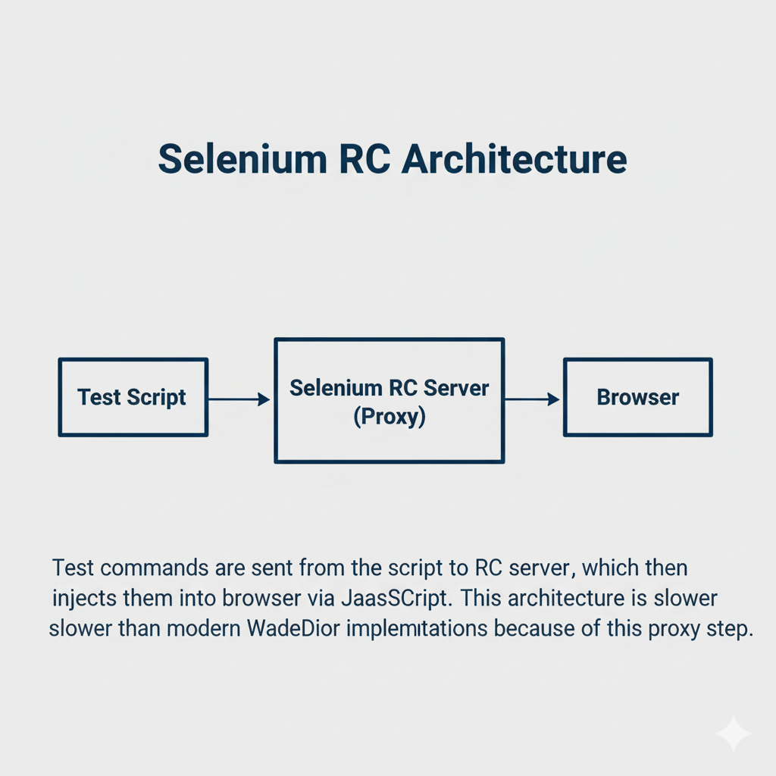
How it Worked (Architecture): Selenium RC used a proxy server architecture to "trick" the browser:
- Selenium RC Server: This was a separate server that you had to start. It acted as a "man-in-the-middle" proxy.
- Test Script: Your test script (e.g., in Java) would send commands to the RC Server.
- The "Trick": The RC Server would then "disguise" itself as the website you were testing. It would fetch the website's content and "inject" the Selenium Core (JavaScript) into it.
- Browser: To the browser, it looked like both the website and the test script were coming from the same place (the RC Server), which bypassed the Same-Origin Policy.
Why it was replaced: This proxy architecture was very slow, complex to set up, and unreliable. Selenium WebDriver (from Selenium 2.0 onwards) was created to solve this by controlling the browser directly, which is a much faster and more stable approach.

Q7. Explain brief history of Selenium.
The history of Selenium is a story of several different tools and people coming together to create the modern standard.
- 2004 - Selenium Core:
  - It all started at ThoughtWorks with Jason Huggins. He was testing an internal web application and created a JavaScript-based tool to automatically run tests in the browser. He called it "JavaScriptTestRunner," which later became Selenium Core.
  - Problem: Selenium Core was limited by the browser's "Same-Origin Policy."
- 2004 - Selenium RC (Remote Control):
  - Paul Hammant, also at ThoughtWorks, created a component called Selenium RC.
  - This component acted as a proxy server to get around the Same-Origin Policy, allowing Selenium Core to test any website. This combination became Selenium 1.
- 2006 - Selenium IDE:
  - Shinya Kasatani in Japan created a "record-and-playback" browser extension to make creating tests faster. This tool was donated to the Selenium project and became Selenium IDE.
- 2006 - WebDriver:
  - At the same time, Simon Stewart (at Google) was working on a separate, rival automation project called WebDriver.
  - WebDriver's goal was different: to control the browser directly at the OS level (using native browser "hooks") instead of using JavaScript or a proxy. This made it much faster and more stable.
- 2009 - The Merge (Selenium 2.0):
  - The creators of Selenium and WebDriver realized they were solving the same problem. They decided to merge the two projects.
  - This new, merged project was released as Selenium 2.0. It had WebDriver as its new "core" API, but still included the old Selenium RC for backward compatibility.
- Selenium 3.0:
  - This version officially removed the old Selenium RC code, solidifying WebDriver as the one true standard.
- Selenium 4.0 (Modern):
  - This version fully adopted the official W3C WebDriver Protocol, which means browser makers (like Google, Mozilla) now build the automation capabilities directly into their browsers, making Selenium a true industry-standard.

Q8. What are advantages of Selenium Web driver?
Selenium WebDriver is the most popular and widely-used tool for web automation because of its many advantages:
- Open-Source and Free: It is a 100% open-source tool. There are no license fees, which makes it accessible for everyone, from individual developers to large corporations.
- Multi-Language Support: WebDriver provides libraries (called "bindings") for many different programming languages. You can write your tests in the language you are most comfortable with, such as Java, Python, C#, JavaScript, or Ruby.
- Multi-Browser Support: It can automate almost every modern web browser, including Google Chrome, Mozilla Firefox, Microsoft Edge, and Apple Safari.
- Multi-Platform (OS) Support: A test script written with WebDriver can be run on any major operating system, such as Windows, macOS, and Linux. A test written on Windows can be run on a Linux machine without any changes.
- Large Community and Support: Because it is so popular, Selenium has a massive global community. This means it is very easy to find tutorials, documentation, forums, and help for any problem you might face.
- W3C Standard: The WebDriver API is now an official W3C (World Wide Web Consortium) standard. This means browser vendors (like Google and Mozilla) build the automation controls directly into their browsers, making tests more stable and reliable.
- Integration Capabilities: WebDriver is designed to be a "core" tool. It can be easily integrated with other powerful tools, such as testing frameworks (TestNG, JUnit, PyTest) and CI/CD tools (Jenkins, GitLab), to build a complete, powerful automation pipeline.

